Assignment 2 - Fundamentals of Data Science

Student Name: Jatan Timilsina

Module: Fundamentals of Data Science

Assignment: Week 3 & 4 Programming Tasks

# 1. Function for Basic Operations

This program creates a function that accepts 2 numbers and displays their sum, difference, product, and remainder.

Output:

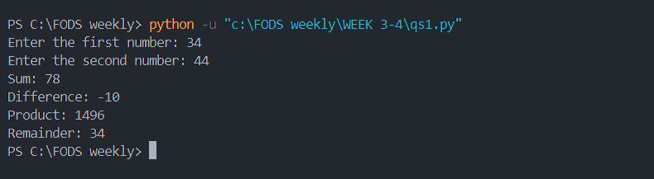

# 2. Functions for All Arithmetic Calculations

This program uses separate functions for each arithmetic operation. Each function takes two user-input numbers and returns the result.

Output:

# 3. Function to Calculate Factorial

This program defines a function that takes a parameter and returns the factorial of the number using recursion or iteration.

Output:

# 4. Function to Count Occurrence in List

This function accepts a list of numbers and prints the occurrence of each number using a dictionary.

Output:

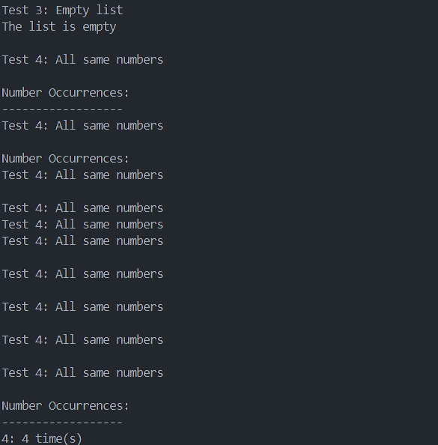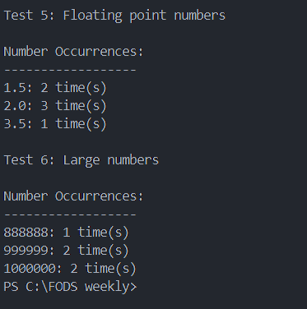

# 5. Function to Sort Names

This function accepts a list of names and returns them in sorted order using Python's built-in sorting.

Output:

# 6. City Search Function in List

This function takes a list of cities and a city to search for, returning the index or a not-found message.

Output:

# 7. Word Frequency Function

This function takes a sentence, splits it into words, and returns a dictionary with the frequency of each word.

Output:

# 8. Remove Duplicates from List

This program takes a list of numbers from the user and returns a list without duplicate values.

Output:

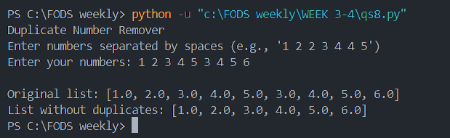

# 9. Book Details in Dictionary

This program collects details (title, author, ISBN, cost) of 5 books from the user, stores them in a dictionary, and prints it.

Output:

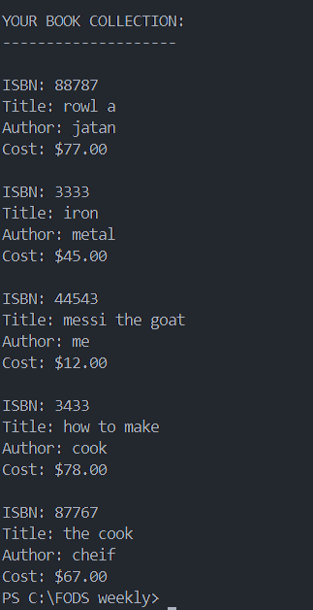

# 10. Even and Odd Segregator

This program continuously accepts numbers, separates them into even and odd lists, and displays them after exiting.

Output:

# 11. Card Guessing Game

This is a card guessing game where the player guesses a card's value and suit. The program evaluates the guess and displays result accordingly.

Output:

